**Mohamed Abdelfattah – 2400027**

**Hesham Abozeid – 2300332**

**Mohamed Ahmed Salah – 2201650**

**Final-term Report**

**Project title:**

Enhancing Alzheimer’s disease classification using Image Processing techniques and CNN model.

**Introduction:**

Alzheimer's Disease (AD) is a progressive neurodegenerative disorder that significantly impacts cognitive function and memory. Early detection and diagnosis are crucial for timely intervention and potential disease management. This report presents an AI-based approach to detect Alzheimer's disease using Magnetic Resonance Imaging (MRI) scans.

**Project Overview:**

We will use the AD dataset from ADNI in kaggle website [2].

We will apply noise on clear images then will use IP techniques as histogram equalization and bilateral filter to remove the noise and increase the contrast stretching, then we will compare the results with origin images and finally we will pass the origin images, noisy images and enhanced images and compare between results through the AI model that will be trained by the same dataset.

**Results**

**IP techniques**

**AI model**

**Noisy images**

**Literature Review:**

There are many studies that have dealt with the same problem and tried to contribute to increasing the accuracy of diagnosis for similar or different diseases as paper “A bilateral filtering-based image enhancement for Alzheimer disease classification using CNN”, we will try to apply more filters on noisy images to deal with most causes that happens in image acquisition stage to improve the detection accuracy as possible. [1]

**Methodology:**

1. **Image Preprocessing:**

* **Noise Reduction:**
  + Applied noise reduction techniques (e.g., Gaussian filtering, Median filtering and Bilateral filtering) to enhance image quality.
* **Normalization and Contrast stretching:**
  + Standardized image intensities to improve model performance (e.g., Histogram equalization).
* **We will apply these IP steps:**
  + **Median filter:** Reduces noises such as salt-and-pepper noise.
  + **Bilateral filter:** it helps remove noise while preserving fine edges and details in the image.
  + **Gaussian filter:** To smooth the image overall and reduce noise. It is useful when there is continuous noise or gradual changes in the image.
  + **Unsharp masking:** To decrease blurring level.

**2- Model Selection and Training:**

* **SVM (Support Vector Machine):**
  + A powerful model for binary and multi-class classification, SVM works well with high-dimensional data and can find optimal decision boundaries, but requires manual feature extraction and is sensitive to noisy data.
* **CNN (Convolutional Neural Network):**
  + A deep learning model ideal for image classification, CNN automatically extracts features from raw images and excels at handling complex patterns in large datasets, but requires substantial data and computational power.
* We will decide which to use after getting the results to select the best model with best metrics.

**Data Collection and Preprocessing:**

* **Source:** Kaggle Alzheimer's Disease Neuroimaging Initiative (ADNI) dataset.
* **Size:** Approximately 18,000 MRI images.
* **Classes:**

|  |  |  |  |
| --- | --- | --- | --- |
| **Class** | **AD** | **MCI** | **NC** |
| **Train** | 7536 | 922 | 7430 |
| **Test** | 810 | 233 | 1220 |

* **Processing Steps:**
  + 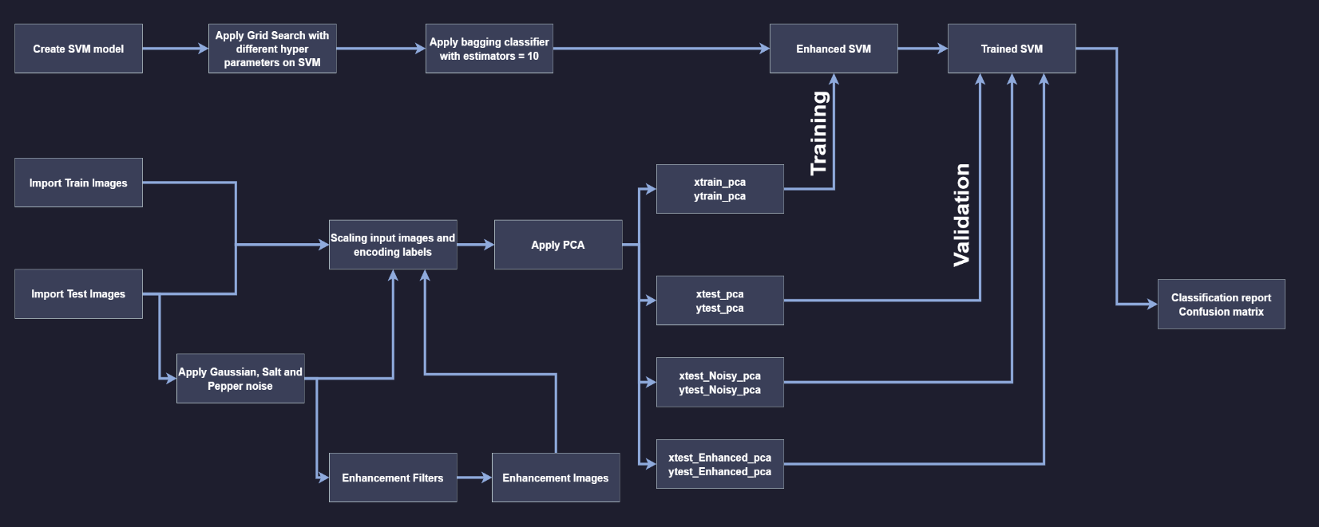**For SVM:**
  + **صورة تحتوي على لقطة شاشة, رسم بياني, خط, خطة

    تم إنشاء الوصف تلقائياًFor CNN:**

**Implementation Details:**

* **Programming languages:** We will use Python as it contains many libraries and functions that help in enhancing images and creating artificial intelligence models.
* **Libraries:** We will need some libraries in Python for IP as:
  + cv2 and PTL: for images.
  + numpy : for image converting to data.
  + matplotlib and seaborn: for displaying graphs.
  + sklearn: for machine learning & data preprocessing.
  + tenserflow: for Deep learning
  + Other libraries for special tasks.

**Experimental Design:**

**For IP:**

1. **PSNR** **(Peak Signal-to-Noise Ratio):** Measures noise reduction quality. Higher values indicate better noise suppression.
2. **SSIM (Structural Similarity Index Measure):** Assesses structural similarity to the original image. Values closer to 1 indicate higher similarity.

**For AI:**

1. **Accuracy**: Percentage of number of correct classified sample to total number of samples.
2. **Precision:** The proportion of predicted positive cases that are actually correct. It measures the accuracy of the positive predictions made by the model.
3. **Recall:** The proportion of actual positive cases that are correctly identified by the model. It measures the model's ability to detect all relevant instances.
4. **F1-score:** Combination of Recall and Precision.

**Focus on Recall:** Prioritized the correct identification of AD cases to enable early intervention

**Results and Analysis:**

**For IP:**

* + First we applied **very high** random noise & contrast corruption on samples images from the 3 classes from the dataset.
  + 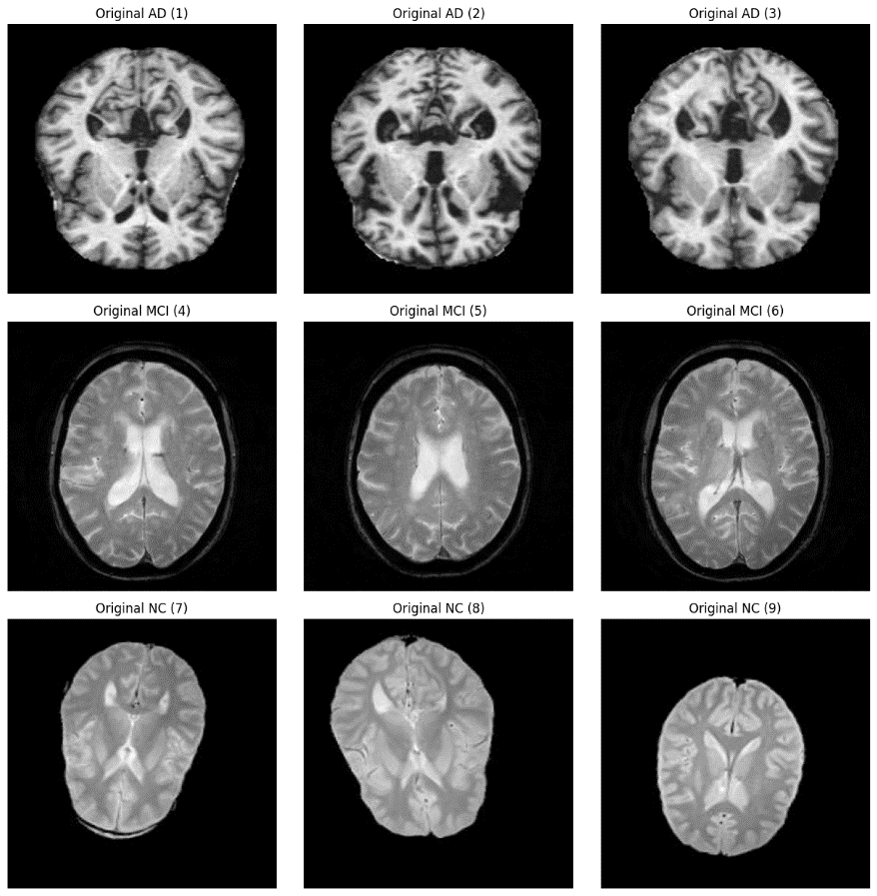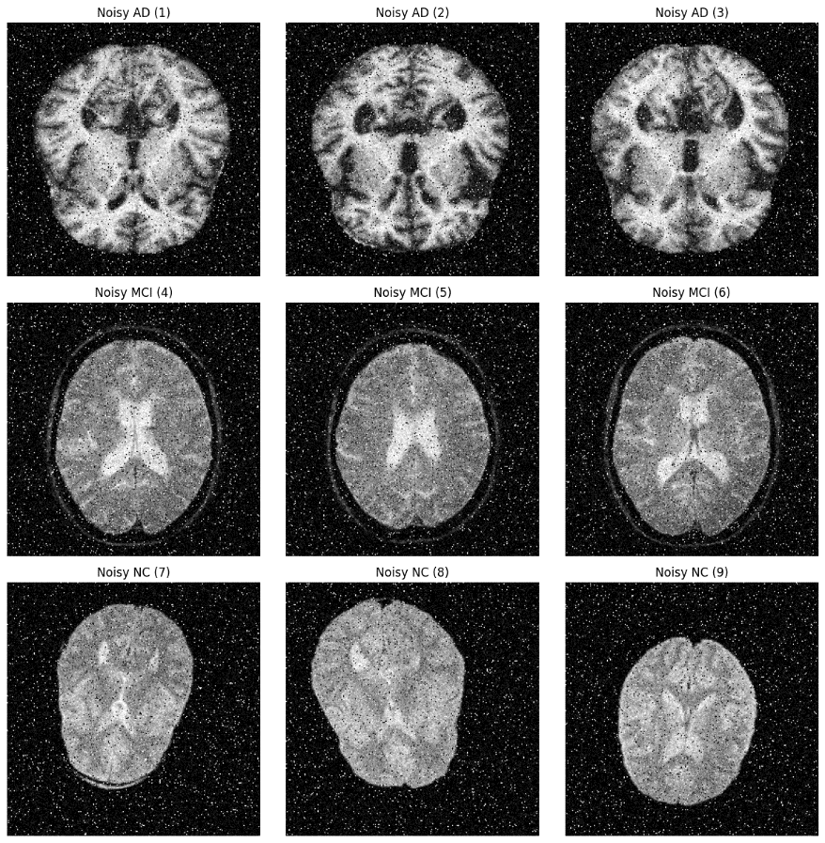Original images vs noisy images:
  + Then we compared every filter on the noisy images to see which one will act better.
  + Performance Metrics after enhancing noisy images:

|  |  |  |
| --- | --- | --- |
| Filter Type | PSNR | SSIM |
| Bilateral Filter | 17.87 | 0.22 |
| Median Filter | 25.47 | 0.48 |
| Gaussian Filter | 20.45 | 0.31 |

* + Third we will apply IP steps as we shown before (Median, Bilateral, Gaussian):

|  |  |  |
| --- | --- | --- |
| Filter Type | PSNR | SSIM |
| Suggested Filters | 25.79 | 0.51 |

* + Apply Histogram Equalization and Skull stripping.
  + Histogram and Image sample of origin sample vs noisy vs enhanced:

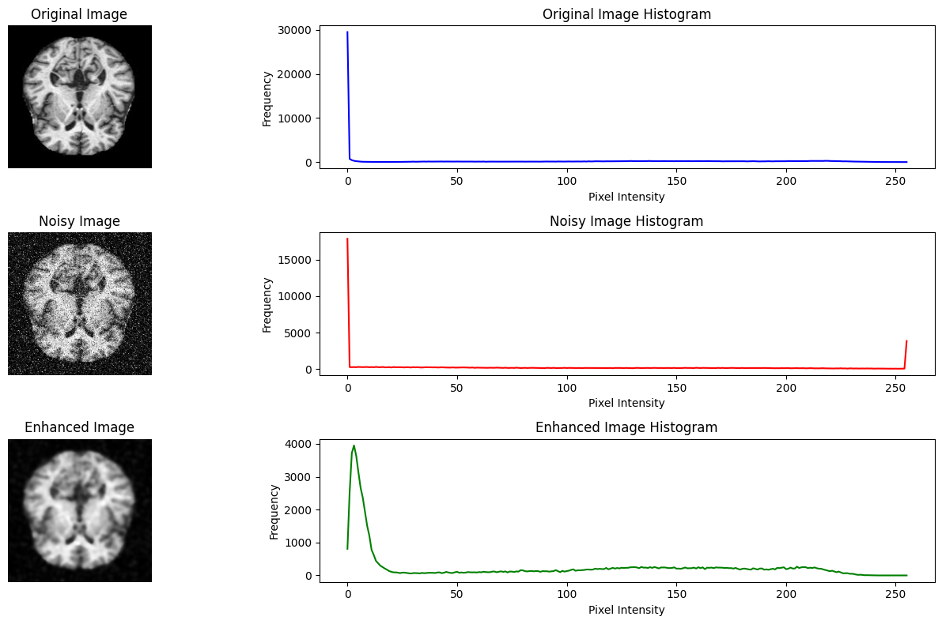

* + Apply skull stripping:

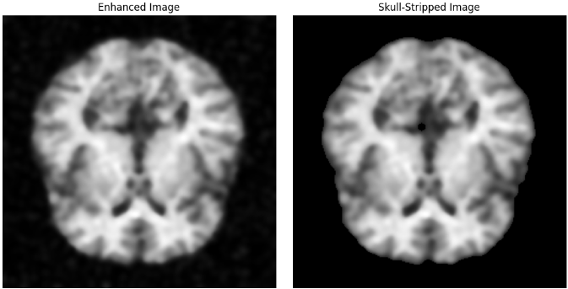

* + Apply unsharp mask to reduce blurring:

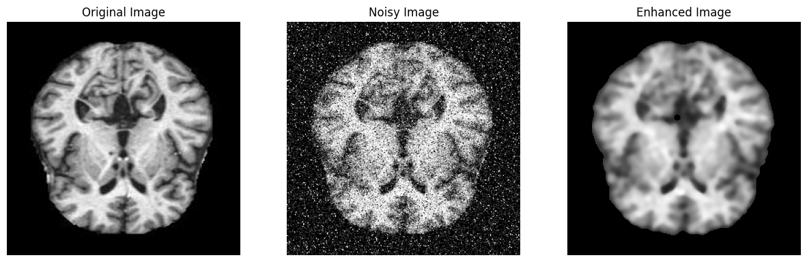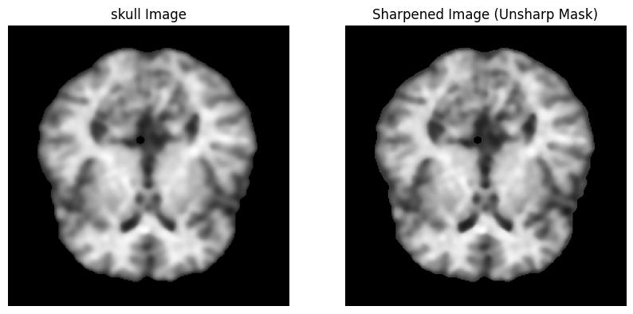

* + Original vs noisy vs enhanced image:

**We can get better result if we decreased the used high rate noise.**

**For AI:**

* SVM:
  + Enhanced SVM with training data set + noisy images + enhanced imagesSVM results from Grid search:

|  |  |  |  |
| --- | --- | --- | --- |
| **Hyper parameter** | **C** | **gamma** | **kernel** |
| **Best parameters** | 100 | scale | rbf |

* + SVM results after enhancing using bagging techniques and then passing the training data then validate with test data:

|  |  |  |  |
| --- | --- | --- | --- |
| **High quality test images** | **Accuracy** | **Recall** | **Precision** |
| **AD** | 98% | 98% | 98% |
| **MCI** | 100% | 89% |
| **NC** | 97% | 99% |

* We can see that the AD detection has increased a little after we increased the training data.
* Recall is a metric that measures how often a machine learning model correctly identifies positive instances (true positives) from all the actual positive samples in the dataset.
* Precision refers to the number of true positives divided by the total number of positive predictions (i.e., the number of true positives plus the number of false positives).
* Our critical metric here is the recall because we care about the detection of AD percentage, we do not need anyone who has the disease to be diagnosed as healthy.

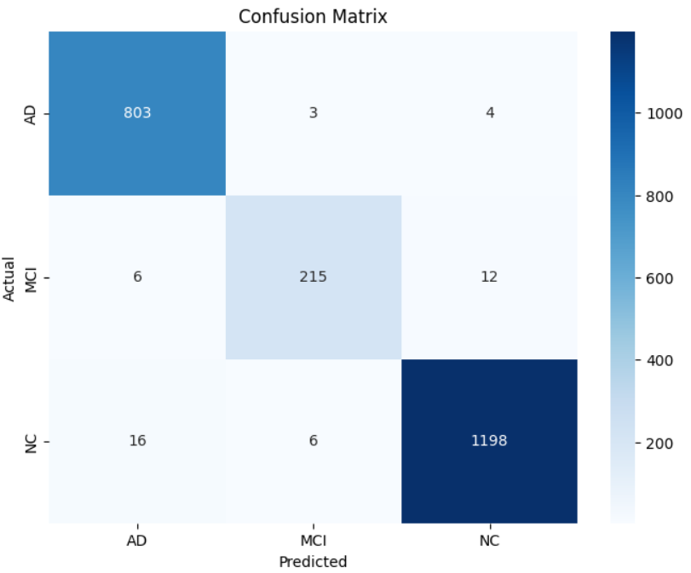

* + Test noisy Images:

|  |  |  |  |
| --- | --- | --- | --- |
| **Noisy test images** | **Accuracy** | **Recall** | **Precision** |
| **AD** | 94% | 96% | 95% |
| **MCI** | 81% | 84% |
| **NC** | 96% | 95% |

* + After enhanced images by different filters:

|  |  |  |  |
| --- | --- | --- | --- |
| **Filter** | **Accuracy** | **AD - Precision** | **AD - Recall** |
| **Suggested** | 94% | 95% | 94% |
| **Median, Gaussian, Unsharp** | 94% | 97% | 97% |
| **Median, Gaussian, unsharp**  **but salt + pepper = 10%**  **Gaussian std = 20** | 95% | 95% | 95% |

* Bagging Classifier: Creates multiple independent training models (usually using random samples with repetitions from the original data) and combines their results (such as voting or averaging) to reduce variance and increase accuracy and stability in prediction.

Help in reduce and solve (overfitting problems).

* PCA: Principal Component Analysis (PCA) is used to reduce dimensionality by extracting the most influential features in the data, which reduces noise and complexity, thus improving the performance and accuracy of the SVM classifier by simplifying the input data.
* CNN:

|  |  |
| --- | --- |
| **Configuration** | **Values** |
| **Conv2D** | 6 layers (32, 64, 128, 256, 512, 1024), size (3,3) |
| **MaxPooling2D** | 6 layers (2,2) |
| **BatchNormalization** | 6 layers |
| **Dense** | 3 layers (1024, 512, 3) |
| **Dropout** | 2 layers (0.5, 0.5) |
| **Epochs & batch size** | 50 & 128 |
| **Early Stop** | val_loss at patience = 10 |
| **Learning rate** | ExponentialDecay(initial = 0.0001) |
| **Optimizer** | adam |
| **Loss** | Focalloss(gamma = 2, alpha = 0.25) |
| **Classweights** | 1.2, 1, 1 for AD, MCI, NC |

* + After testing high quality images:

|  |  |  |  |
| --- | --- | --- | --- |
| **High quality test images** | **Accuracy** | **Recall** | **Precision** |
| **AD** | 97% | 98% | 98% |
| **MCI** | 86% | 98% |
| **NC** | 99% | 96% |

* SVM are better by 1% in total accuracy, it is better then CNN in detecting MCI while CNN is better at detecting NC, they two act the same way in AD detection.

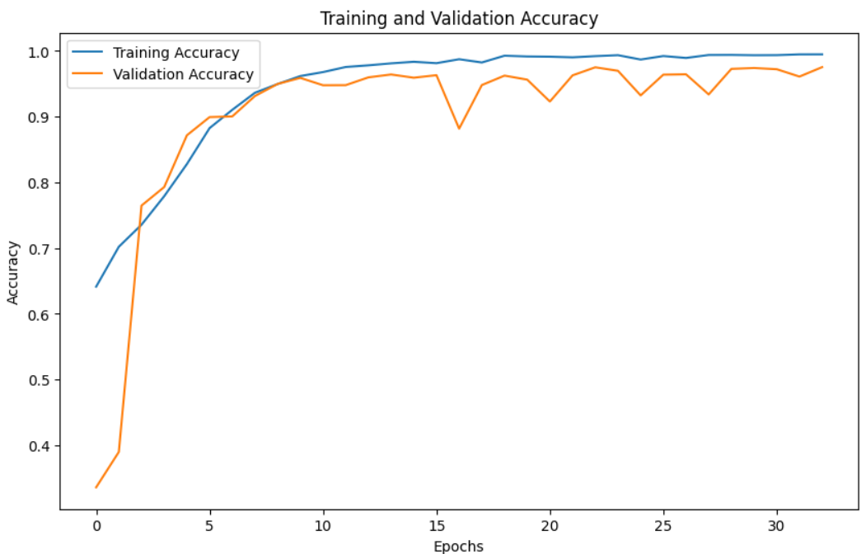

* It seems that the data is so simple for CNN, because CNN reached high training & validation in early stage and then the accuracy just increase and decrease as model training, with out any noticeable progress
  + After testing noisy images:

|  |  |  |  |
| --- | --- | --- | --- |
| **Noisy test images** | **Accuracy** | **Recall** | **Precision** |
| **AD** | 84% | 83% | 92% |
| **MCI** | 23% | 79% |
| **NC** | 96% | 80% |

* + 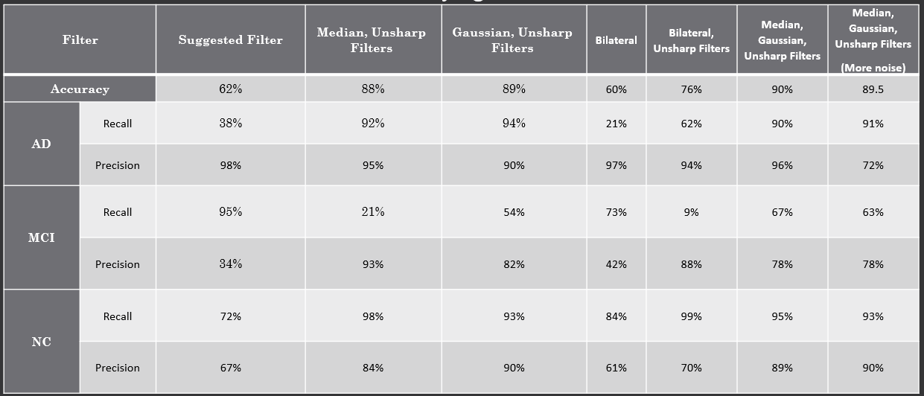After testing enhanced images with different filters:
* Bilateral filter that was suggested in the research, cause model to have low accuracy than median or gaussian.
* Best stable results was generated in the case of using Median, Gaussian and unsharp masking.
* Increasing the noise level did not show a noticeable change in accuracy.
* Although the accuracy is much less than SVM model, CNN appear to be more stable vs noises, but it is hard to reach the desired results.
* Why can’t we use some enhancement techniques like we did to SVM ?
* If we use PCA, there is no benefit to using CNN as CNN extracts features automatically instead of using PCA which will take this role from it. PCA can be used first in case the data is very complex, and it is used to reduce the complexity a little on CNN but in our case the main problem is that the data is very easy for CNN so it did not learn well how to deal with completely new images but it did not perform badly as if it had never learned them.
* So how do we solve the problem to get an accuracy similar to SVM or higher?
* We must increase the number of images and increase their level of complexity by adding some different noises to them and tampering with their TRANSFORM such as moving the skull position or making it rotate at an angle...etc.
* This will increase the level of difficulty of the data for the model, which makes it able to learn it effectively.
* The problem we will face in this case is the lack of sufficient resources for the command (ram & CPU).

**Discussion:**

As we saw before from the different results: The model performed well in all different cases, including testing it with high-resolution images, images with noise, or images after processing with different filters.

Unlike the proposed model, but this does not mean that the proposed model is bad, it just did not take its full chance because it needs high-level computers, unlike the other model that has received many developments to reach this accuracy.

Let's not forget that the model performed well in the face of increased noise and that it is more flexible and stable, it just needs a huge amount of different and difficult data to learn well.

**Conclusion:**

**IP part:**

* Median Filter achieved the highest PSNR (25.47) and SSIM (0.48). This makes it the most effective for Salt-and-Pepper noise and general noise reduction while preserving structural details.
* The Gaussian Filter performed slightly better than the Bilateral Filter in terms of PSNR, but it struggled with SSIM, indicating some loss of structural information.
* The Bilateral Filter maintained edges but had lower overall metrics compared to the other two techniques.
* We combined these filters to get highest PSNR (25.49) and SSIM (0.51).

**AI part:**

* SVM is better than CNN in dealing with data that has a limited number and is small, which is simple data that is not complex or has many details.
* In a case such as identifying Alzheimer's, it is preferable to use SVM.
* You can use CNN if you fear the effect of noise on the accuracy of the SVM, because by increasing the noise rate, the accuracy will decrease significantly in the SVM compared to the CNN (even if it is processed, as we tested previously).
* If the level of data complexity increases, it is preferable to use CNN to obtain the best results.
* Choosing the appropriate filter depends on the rate and type of noise in the image, but if we talk about the possibilities that we have, it is better to use the proposed method or the method that gave the best results by removing the bilateral filter from the proposed method.

**References:**

1. **Project Paper based:** <https://journals.plos.org/plosone/article?id=10.1371/journal.pone.0302358>
2. **Dataset:**

<https://www.kaggle.com/datasets/kaushalsethia/alzheimers-adni/data>

1. **GitHub Link:**

<https://github.com/MohamedAbdelfattah-SHA/Alzheimer-s-disease-classification>